WIREFRAME
index.html

Authorize/Login
LEDGER FLOW

home.html (invoice ledger)
LEDGER FLOW
Invoice Ledger

Invoice Ledger
Client Registry
Pay Dashbaord
Export Dashboard

X Log Out Session

home.html (Client Registry)
LEDGER FLOW

Client Registry
Invoice Ledger
Client Registry
Pay Dashbaord
Export Dashboard

X Log Out Session

home.html (pay Dashboard)
LEDGER FLOW

Pay Dashboard (Maturity Ledger)

Invoice Ledger
Client Registry
Pay Dashbaord
Export Dashboard

X Log Out Session

home.html (Export Dashboard)
LEDGER FLOW

Document Finalization

Invoice Ledger
Client Registry
Pay Dashbaord
Export Dashboard

X Log Out Session

SITEMAP
Log Out
Client Registry
Export Pdf
Pay Dashboard
Invoice Ledger
login
LEDGERFLOW

OUTPUT/SS
index.html
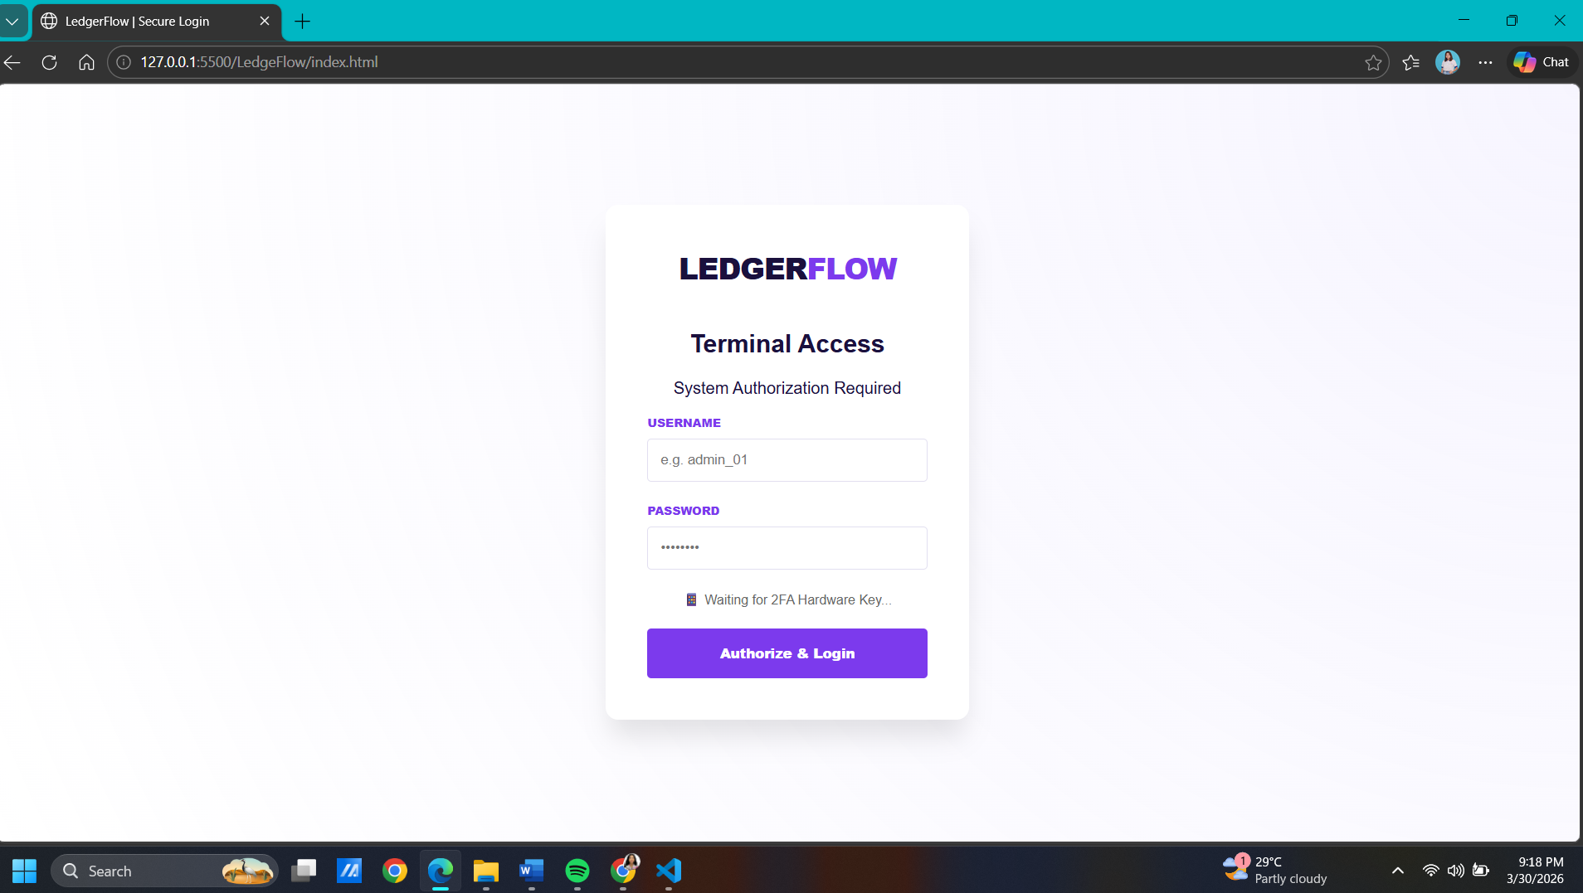

home.html
